# Chapter 2 – Organizational Profile

***About Flipcarbon Integrated Solutions Pvt Ltd***

Flipcarbon Group was established in 2014 with the aim of providing comprehensive strategies, meticulous execution designs, and effective deployment solutions to organizations driven by growth. They collaborate closely with startups, small and medium-sized enterprises (SMEs), micro, small, and medium-sized enterprises (MSMEs), large multinational corporations, and family-run businesses to unlock the untapped potential of their ventures.

Flipcarbon's way of doing things is based on some key ideas:

1. **Dedication to Fast Growth:** At Flipcarbon, they're all about helping their clients grow quickly. They know it's important to reach growth goals fast, so they work hard to show real results within set timeframes.
2. **Building a Growth-Friendly Culture:** They've created a special work environment that gives their clients the freedom to drive growth projects on their own. But at the same time, they keep an eye on costs, making sure things stay financially sound.
3. **Embracing Skills and People Smarts:** Flipcarbon doesn't just understand the nitty-gritty of starting new projects; they also get how important people are in these ventures. They know that success comes from not only putting new ideas into action but also supporting the people who make innovation happen.
4. **Developing Competitive Team Members:** Flipcarbon really focuses on building a team that has the right skills and knowledge to thrive in a tough business world. They encourage their team to keep learning and growing, making sure they can deliver great results for their clients.

Flipcarbon's Virtual CFO & Accounting Services play a big role in what they do. This part of their work focuses on giving top-notch financial advice and accounting help, acting as a reliable partner for their clients. The way Flipcarbon does things is like how carbon forms special bonds in certain situations. They take inspiration from this and use a "specific-solution-to-specific-issues-of-specific-client" approach. Just like carbon creates unique connections under certain conditions, Flipcarbon aims to make customized solutions by using the unique aspects of each client's situation. This way, they can create one-of-a-kind plans and fixes that tackle the specific challenges their clients are dealing with.

***Background and Current Description***

Flipcarbon Integrated Solutions Private Limited is a private company that was established on December 4, 2014. It's categorized as a private limited company and is situated in Bangalore, Karnataka. The authorized share capital of the company is INR 1.00 Cr, and the total paid-up capital is INR 91.50 lac. The company specializes in offering HR & Financial Consulting, complete HR & Financial Outsourcing, Modular HR Services, and Financial Services.

***Products & Services of CFO Vertical:***

CFO Advisory, Accounting, taxation and MIS services, Payroll processing, Handling PF and ESI Compliances, Company secretary functions for Indian Private Limited Companies. Virtual CFO, Accounting & Bookkeeping Services for Growing Startups & Businesses. Cashflow, Cost & Working Capital Management, Business Plans, Valuation Modelling & Financial Modelling, Board & Management Reporting, Investment Advisory, Transaction Support, Fundraising, Financial Strategy & Planning

***Our Team***

Flipcarbon Integrated Solutions Private Limited was founded on December 4, 2014. It's a private company in Bangalore, Karnataka, with an authorized share capital of INR 1.00 Cr and a total paid-up capital of INR 91.50 lac. The company provides HR & Financial Consulting, end-to-end HR & Financial Outsourcing, Modular HR Services, and Financial Services.

There are three directors in the company, and Prabhash Nirbhay, the founder, has been serving since the beginning. Lokesh Mehta joined on August 10, 2015, and Alok Ranjan, who is also the current acting CEO, was appointed on March 1, 2018. Prabhash Nirbhay is involved in six companies and connected to five others through his directorships.

The Bangalore branch has 13 employees, and overall, Flipcarbon has a network of over 30 experts across three branches. The CFO vertical, where the author interned, is led by Mr. Deepak Kewalramani, a pro with almost three decades of financial analytics and strategic advisory experience. The author reported to Mr. Bharat Karnani, a CA with 15 years of financial consulting experience, and Ms. Pramila Lakra, with nearly five years of experience in Financial Due Diligence and Forecasting. The organization needed a business intelligence expert to make financial statements and visualizations using Microsoft Suite and Power BI. The author, with a finance and business analytics background, was a good fit. Drawing from their experience as a business analyst, they proposed a framework for integrating solutions using a tech-stack approach (SaaS). With over 500 years of collective management experience, eight years of consulting, and 170+ satisfied clients, Flipcarbon aims to be the gold standard in management consulting.

***Mckinsey’s 7s Framework***

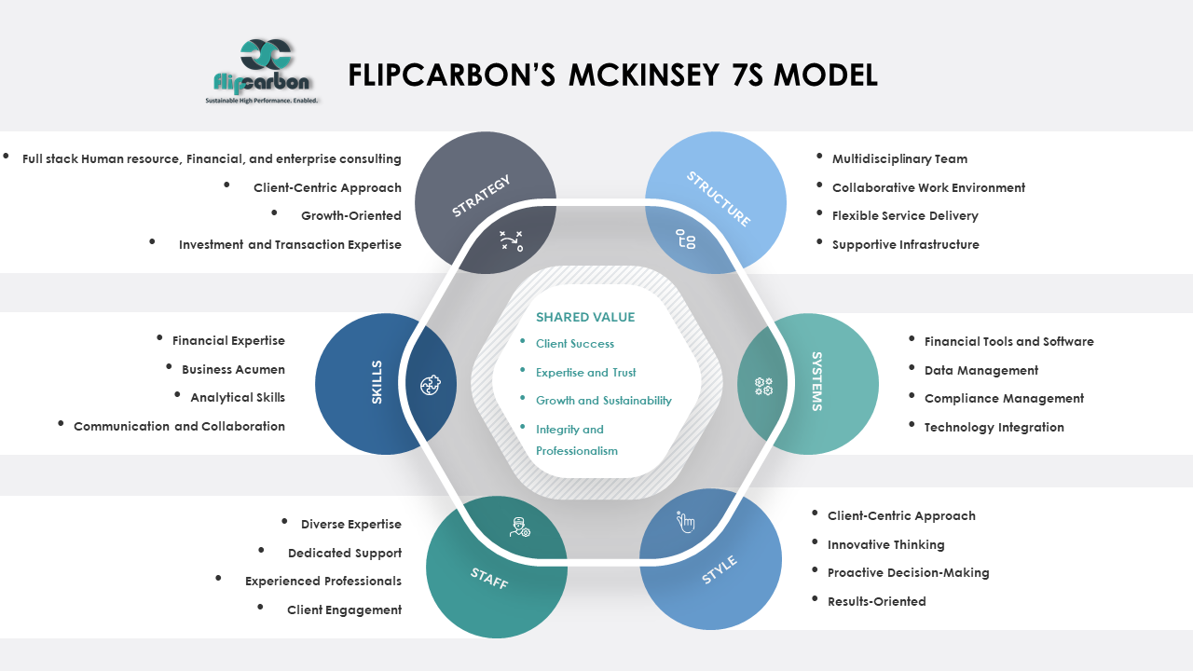

**Strategy**:

* Full stack Human resource, Financial and enterprise consulting: Flipcarbon's strategy encompasses a wide range of financial services, human resource consulting and other services tailored for start-ups and growing businesses.
* Client-Centric Approach: Their strategy is client-focused, aiming to provide tailored financial advice and support to meet clients' specific needs.
* Growth-Oriented: The strategy emphasizes helping clients grow, scale, and achieve sustainable financial outcomes, learning and development, capability transformation etc.
* Investment and Transaction Expertise: Flipcarbon assists clients in fundraising, investments, and M&A activities, aligning with a strategic approach to financial growth as well as human resource capability transformation services.

**Structure**:

* Multidisciplinary Team: Flipcarbon has assembled a diverse team of business partners, principal consultants, client engagement managers.
* Collaborative Work Environment: Their structure promotes collaboration and teamwork to deliver comprehensive financial solutions.
* Flexible Service Delivery: The organization's structure allows for adaptability in providing financial services customized to individual client requirements.
* Supportive Infrastructure: Flipcarbon likely employs technology and tools to facilitate financial modelling, accounting, and advisory services.

**Systems**:

* Financial Tools and Software: Flipcarbon employs financial modelling tools and accounting software to manage client finances effectively.
* Data Management: They have systems in place for data collection, analysis, and reporting to support financial decision-making.
* Compliance Management: Systems are implemented to ensure clients' financial compliance, including GST returns and tax-related matters.
* Technology Integration: The organization likely integrates technology solutions to streamline financial processes and improve efficiency.

**Shared Values**:

* Client Success: The shared value is client success, with Flipcarbon striving to help clients achieve their financial goals and benchmarks.
* Expertise and Trust: They value expertise and trust, as indicated by their emphasis on having a team with a cumulative experience of over 400 years.
* Growth and Sustainability: Flipcarbon's shared values align with the growth and sustainability of their clients' businesses.
* Integrity and Professionalism: Integrity and professionalism are likely core values, given their role in financial advisory and compliance.

**Skills**:

* Financial Expertise: The team possesses financial expertise in areas such as financial strategy, accounting, and investment advisory.
* Business Acumen: They have a strong understanding of business operations, enabling them to provide valuable financial insights.
* Analytical Skills: Skills related to financial modeling, budgeting, and sensitivity analysis are essential for their services.
* Communication and Collaboration: Effective communication and collaboration skills are likely vital to interact with clients and within the team.

**Style**:

* Client-Centric Approach: The leadership style emphasizes client needs and satisfaction.
* Innovative Thinking: A culture of innovation might be encouraged to find creative financial solutions.
* Proactive Decision-Making: Leaders may take a proactive approach to guide clients in making sound financial decisions.
* Results-Oriented: The organizational culture may prioritize achieving tangible financial outcomes for clients.

**Staff**:

* Diverse Expertise: The team comprises individuals with diverse skills and backgrounds, contributing to a holistic approach to financial services.
* Dedicated Support: The inclusion of "Dedicated Accounts Executive" and "Dedicated Engagement Manager" suggests a commitment to personalized client support.
* Experienced Professionals: The team includes professionals with 3-15 years of experience, demonstrating a blend of youth and experience.
* Client Engagement: Monthly meetings and unlimited phone support indicate an active engagement approach with clients.